# HOME

### Welcome

Welcome to the GUIDEz website, where you will find every important guide for all your favourite games. The website is still in development so only a few games have guides available.

### About Me

My name is Gergő Golyha and I am a first year CS student at Eötvös Lóránd University in Budapest, Hungary. Gaming has always been a significant part of my life and my passion is still with me to this day, that’s the reason why I’m working on this website.

### All In One Place

Throughout the years spent playing many games from many different genres, I’ve realized that I’m searching for the same obscure reddit post about some mechanic or wiki page about drop chances more than I’d like to admit. I’d always end up with 15 different tabs open and 30 sites bookmarked, so I’d need to organize them into folders and subfolders and so on, but keeping track of them all would become quite the hassle.

This website aims to alleviate this issue of having to remember everything by archiving not just the links but the name and category of the guides that I, or anyone, would want to use later.

## My Favourites

Here are a few of my favourite games and the links their guide pages.

### Minecraft

Minecraft is a game made up of blocks, creatures, and community. You can survive the night or build a work of art – the choice is all yours. But if the thought of exploring a vast new world all on your own feels overwhelming, then fear not! Let’s explore what Minecraft is all about![1]

### Warframe

In Warframe, players control members of the Tenno, a race of ancient warriors who have awoken from centuries of [suspended animation](https://en.wikipedia.org/wiki/Suspended_animation) far into [Earth's](https://en.wikipedia.org/wiki/Earth) future to find themselves at war with different factions in the Origin System.[2]

# HOME képek

Logo(minden oldal fejlécén):



Me:

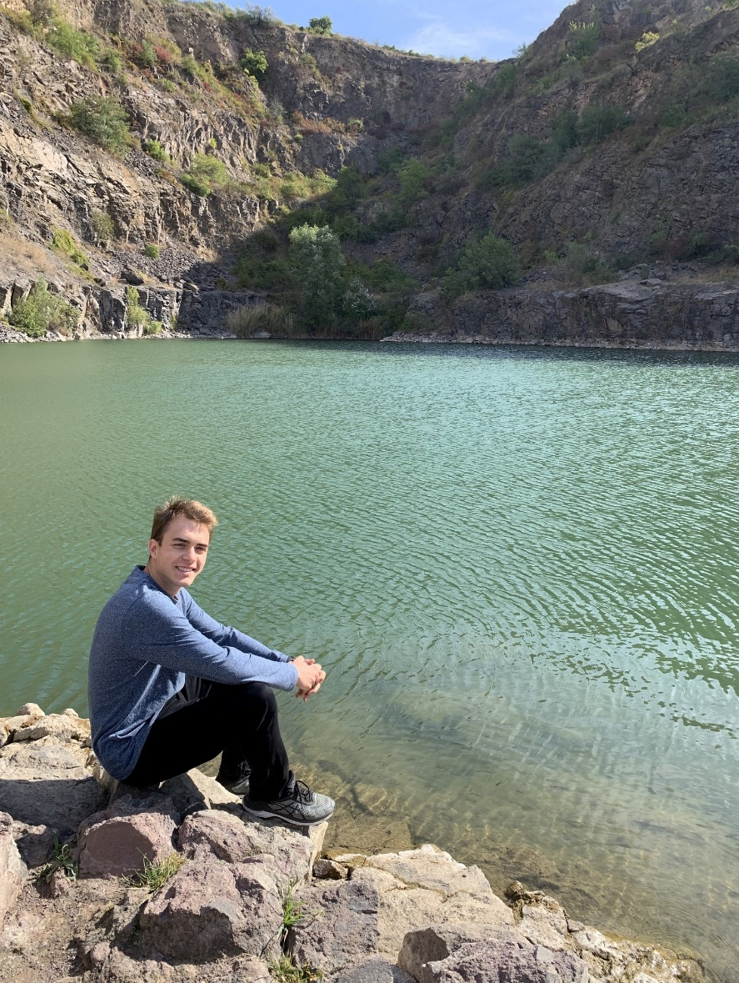

Minecraft:

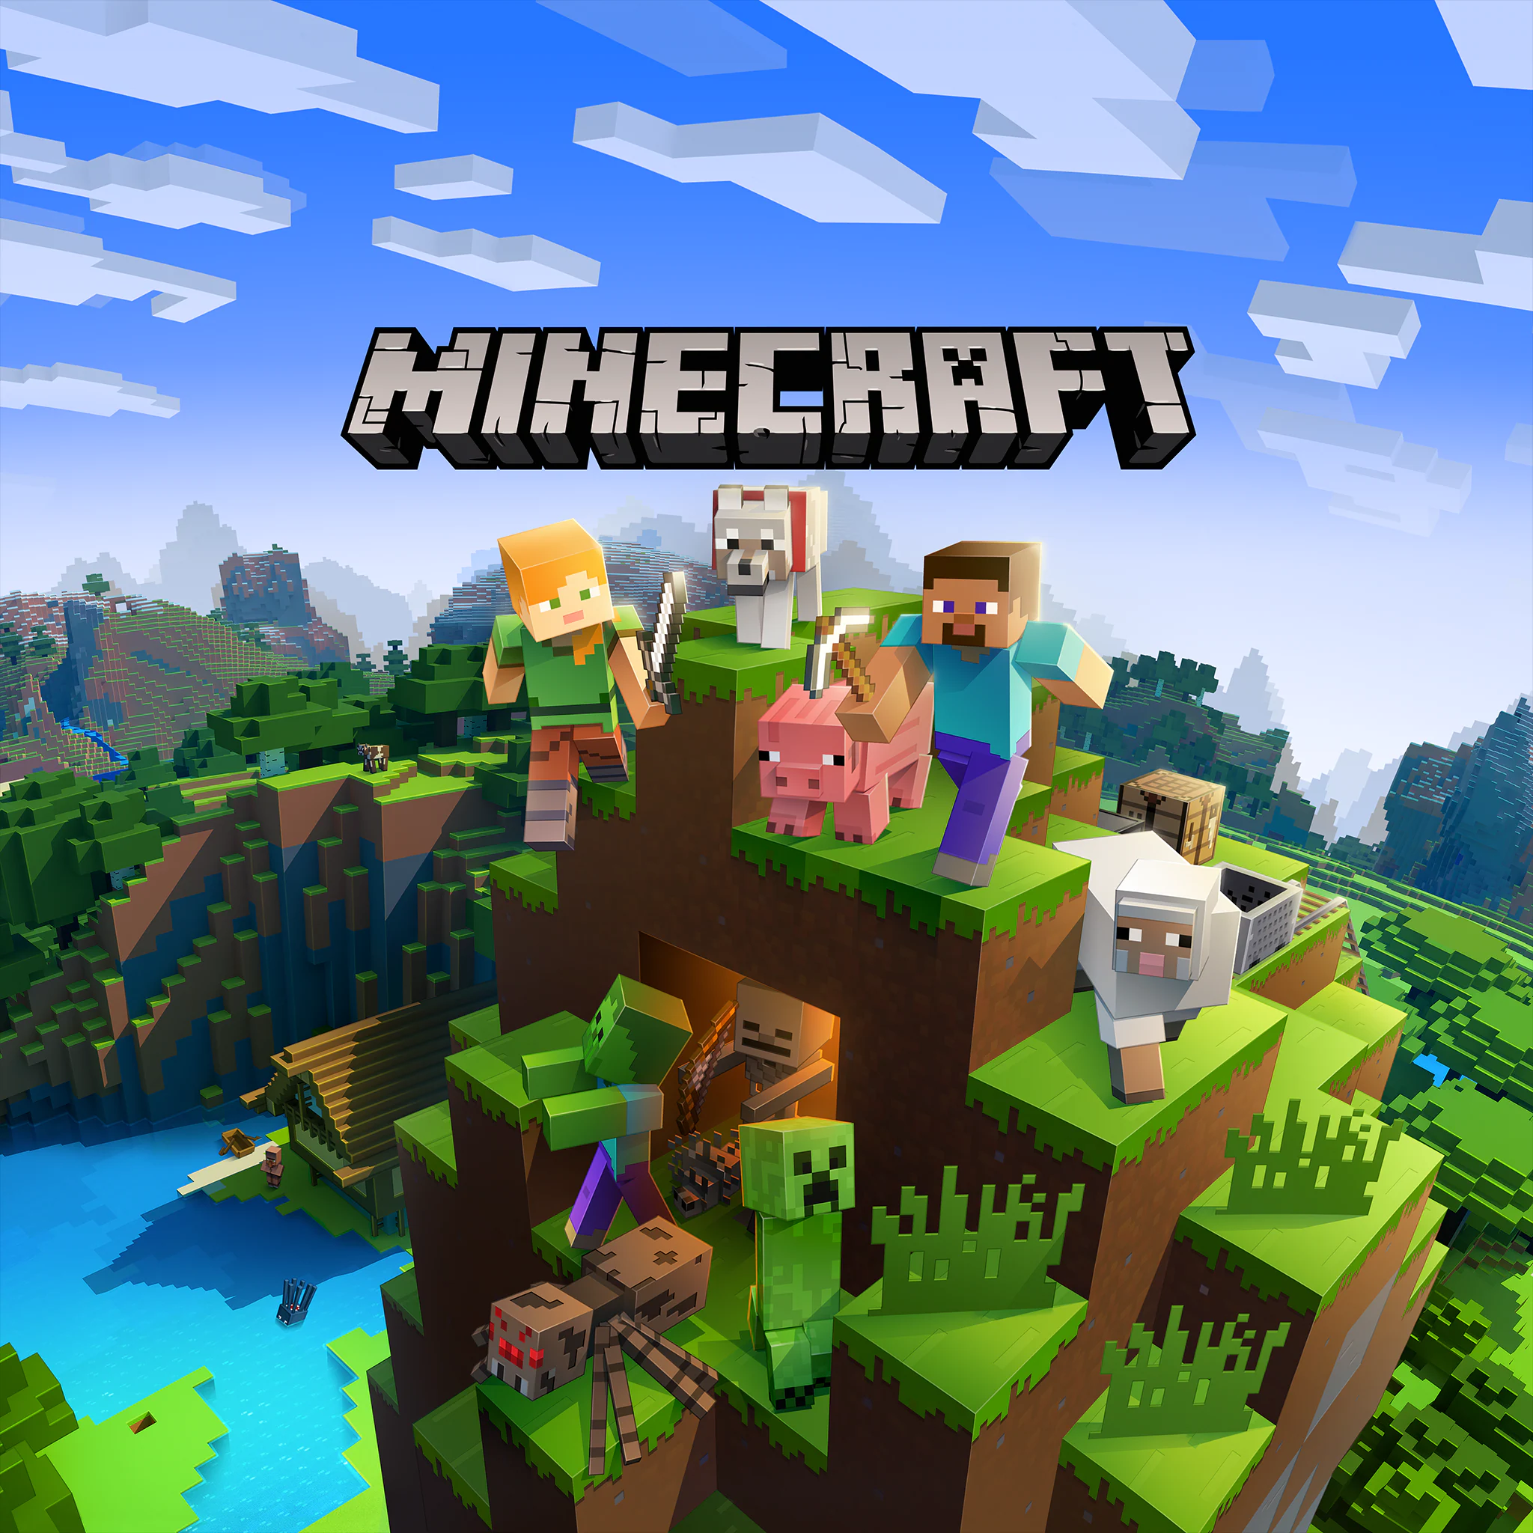

# HOME képek

Warframe:

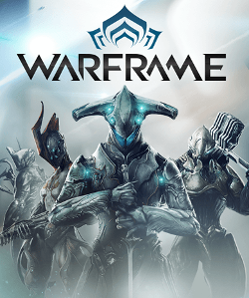

# GAMES

Here you’ll find the list of all games that have a GUIDEz page. The list and the categories are always expanding, so don’t be sad if your favourite game is missing. In addition, you can always go to the SUBMIT page from the menu at the top of the site and fill out the form to submit a link that you think should be part of GUIDEz.

## Minecraft

### Enigmatica 2 Expert

Enigmatica 2: Expert is an expert questing modpack for Minecraft 1.12 with over 650 quests to guide you along the way. The goal of the pack is to complete the Bragging Rights questline - Crafting one of every craftable creative item.[3]

### Nomifactory

Nomifactory (ファクトリーのみ) is a quest-driven expert pack focused on building large-scale factories, where you will put your automation skills to the test as you progress from punching trees to creative-in-survival, climbing the power tiers of GregTech: Community Edition (GTCE) and its extension, Shadows of Greg. No complicated magic systems, no forced combat or exploration: Only Factories![4]

## Warframe

### Builds

Here you’ll find a list of my favourite builds in the game. Most of them are from overframe.com but some come from YouTube or Reddit.

### Wiki Pages

As the name implies, this page contains the most important wiki pages for casual gameplay.

## Factorio

### Blueprints

A collection of blueprints from factorioprints and YouTube.

### Mods

Mods and anything related to them.

# GAMES képek

E2E:

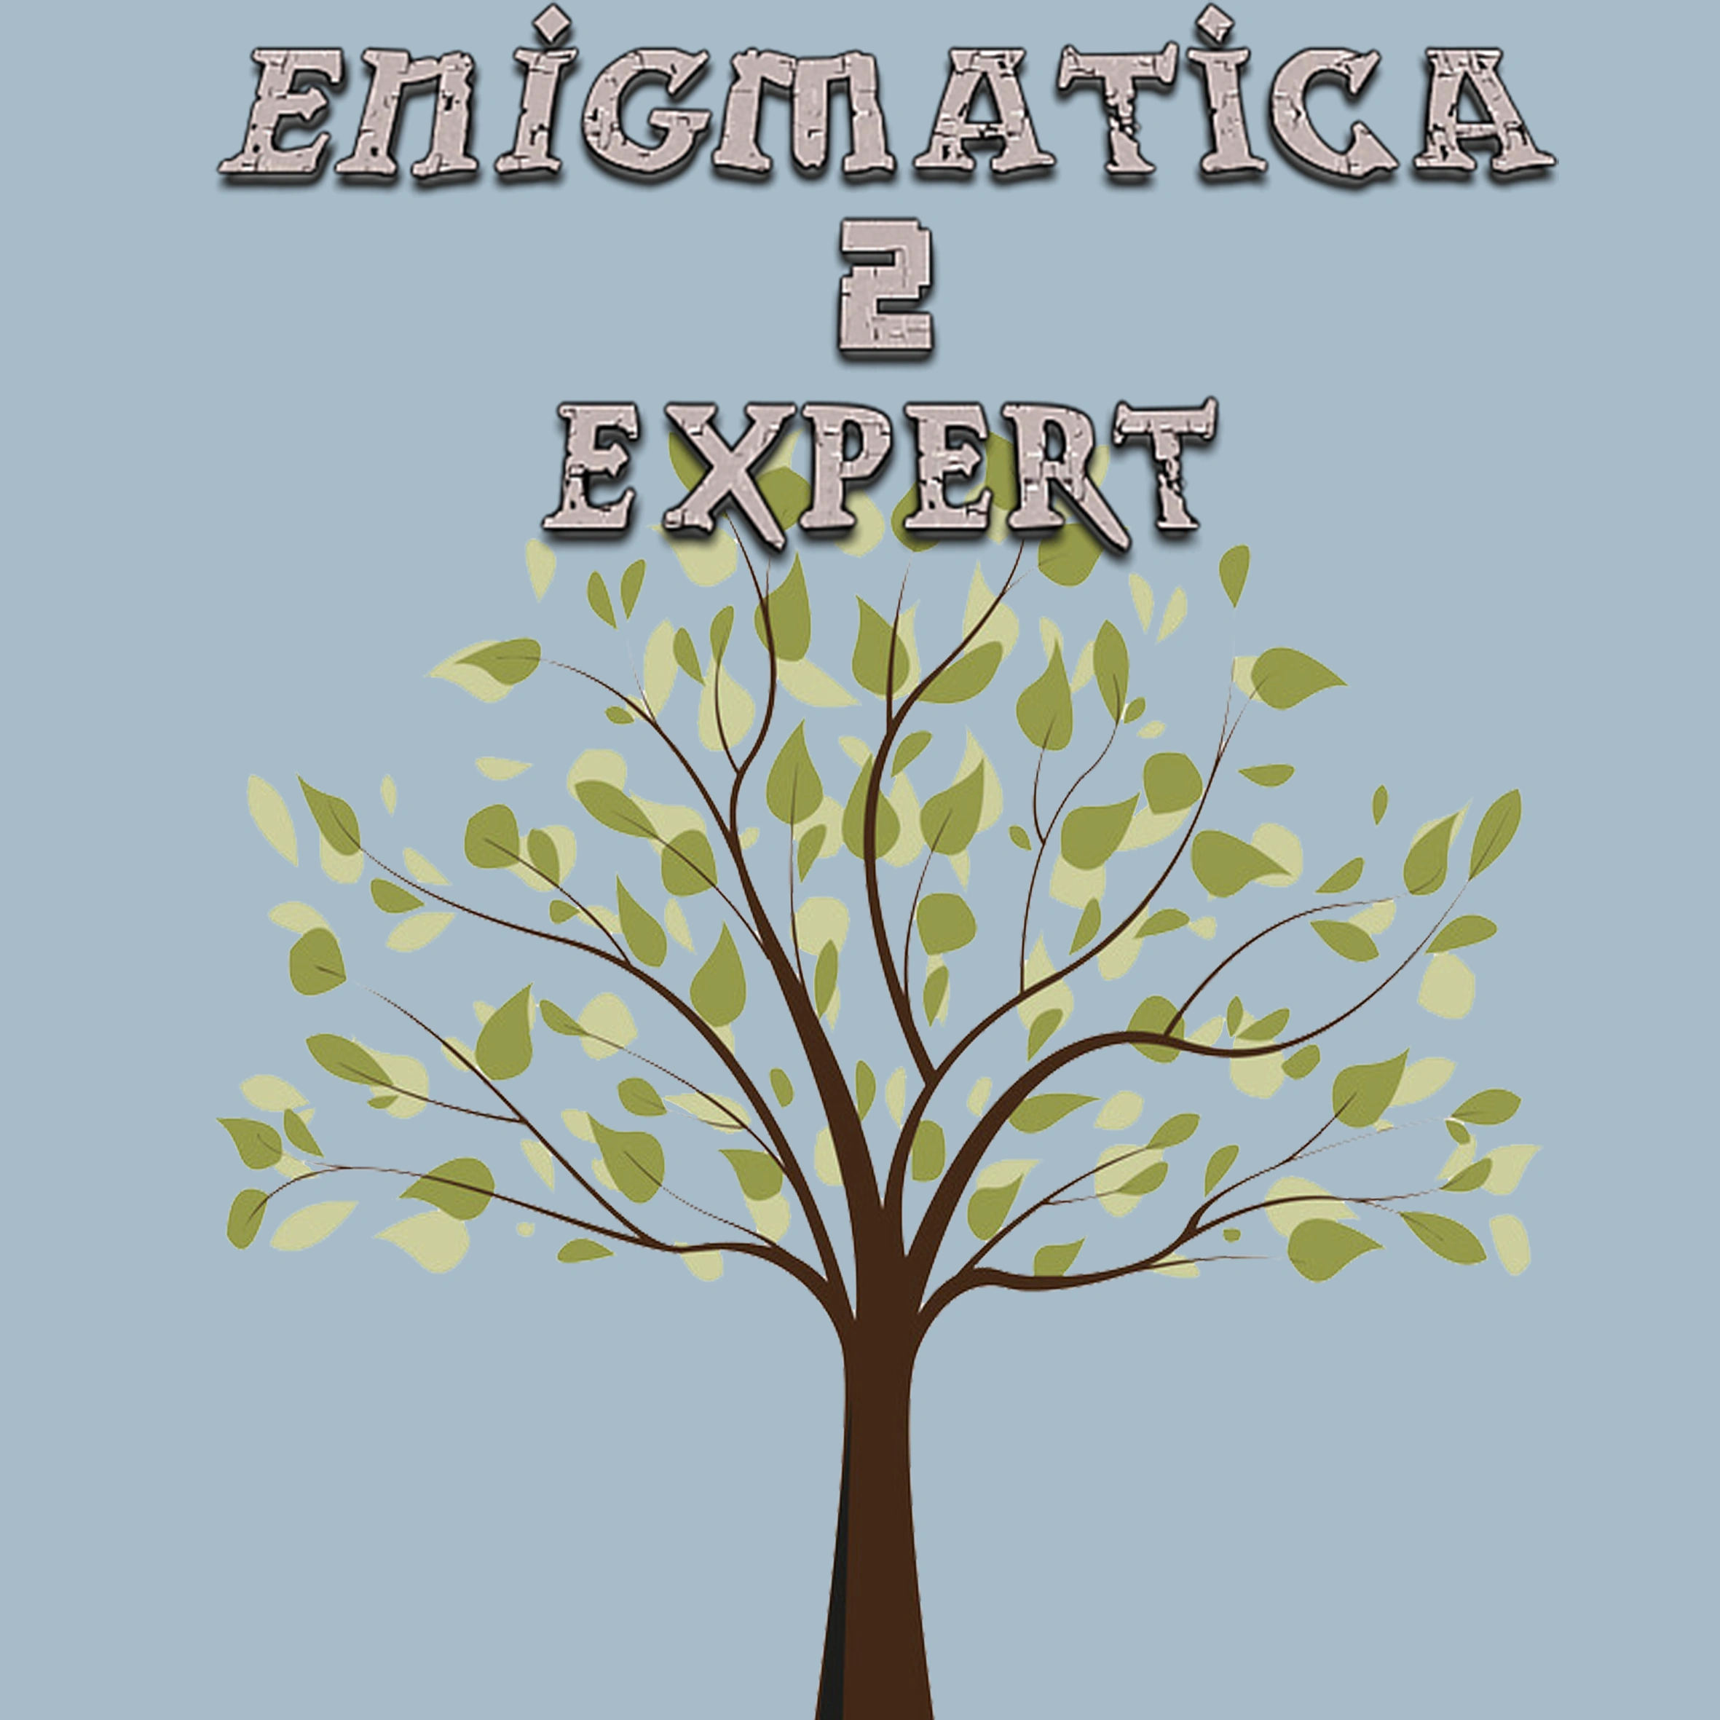

Nomifactory:



Builds:



# GAMES képek

Wiki:

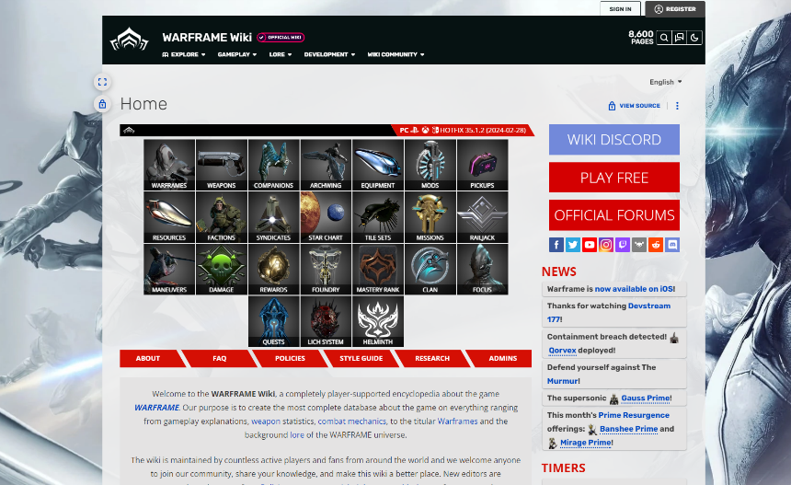

BP:

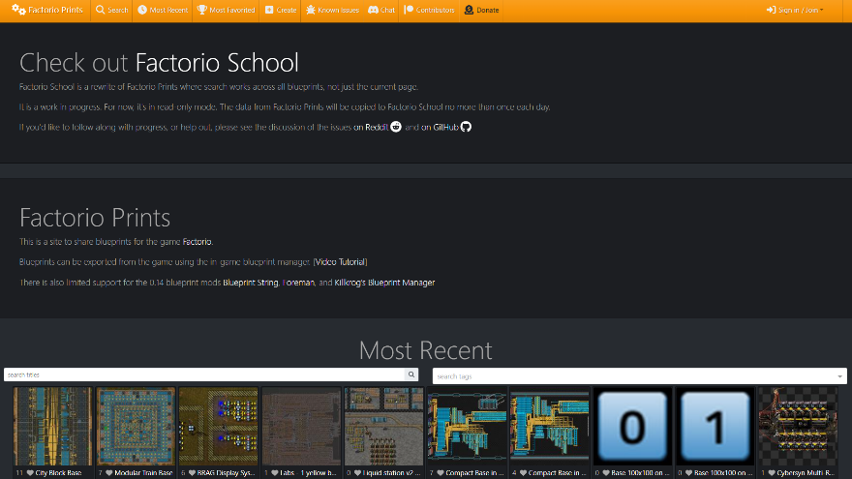

Mods:

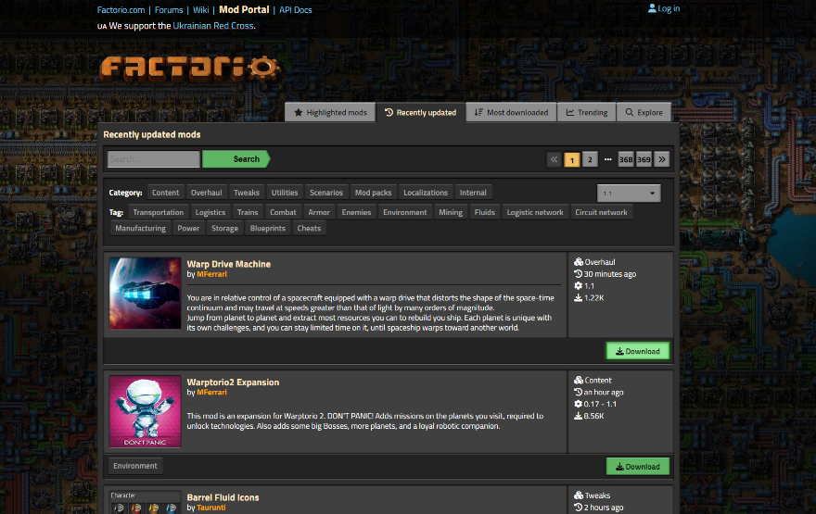

# SUBMIT

### How To

The video to the right will show you how to submit a link to be added to GUIDEz.

The process is simple: fill out all the necessary information and click the submit button.

If you get lost, you can always click the reset button to wipe the form and start from a clean slate!

# SUBMIT video

<https://www.youtube.com/watch?v=QYOiEHXl3oQ>

Ez a video csak placeholder, amint elkészül a tényleges weboldal, akkor fogok készíteni egy megfelelő videót, addig ez helyettesíti, ezzel teljesítve a video követelményt.

VAGY: <https://www.youtube.com/watch?v=MmB9b5njVbA>

# SUBMIT űrlap

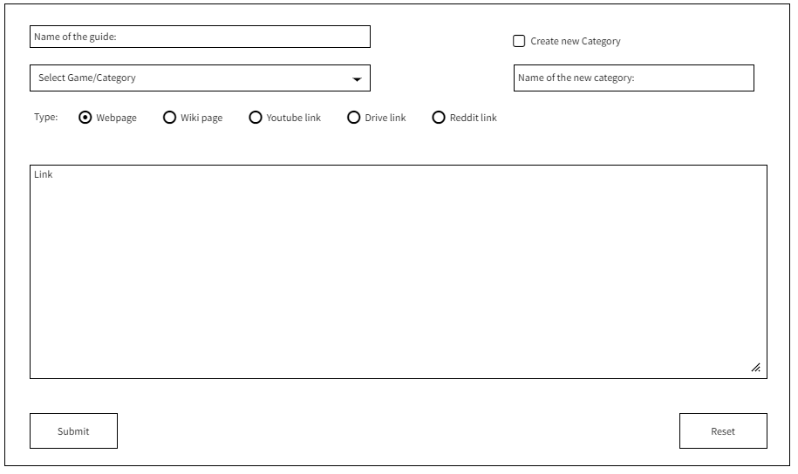Az űrlap megtalálható a drótváztervben is a piros megjegyzések nélkül.

checkbox

text

button

button

dropdown

radio

textarea

text

# MINECRAFT

### About

Minecraft is a game made up of blocks, creatures, and community. You can survive the night or build a work of art – the choice is all yours. But if the thought of exploring a vast new world all on your own feels overwhelming, then fear not! Let’s explore what Minecraft is all about![5]

Minecraft also has a sprawling modding scene with thousands of mods spanning from automation and magic to decoration and quality of life! Modpacks are special collections of mods where the authors modify the mods to suit some overall objective, be that a specific goal or a greater sandbox experience.

|  |  |  |  |
| --- | --- | --- | --- |
| **Name** | **Link** | **Subcategory** | **Type** |
| Thaumcraft Essentia System | [here](https://imgur.com/a/XU8sWXa) | E2E | Webpage |
| Thaumcraft Runic Matrix | [here](https://www.youtube.com/watch?v=DqfTcWuDXAk) | E2E | YouTube link |
| NuclearCraft Fission Reactor Design Generator | [here](https://leu-235.com) | E2E | Webpage |
| AE2 Item Access Priority | [here](https://www.reddit.com/r/feedthebeast/comments/f7txz2/ae2_item_access_priority/?rdt=56345) | Nomifactory | Reddit link |
| Nomifactory Github Guides | [here](https://github.com/Nomifactory/Guides/tree/latest/guides) | Nomifactory | Webpage |
| Draconic Evolution Fusion Core Automation | [here](https://docs.google.com/document/d/1zEIuXb8tfPnVT5QIOip37LDFWHo7HKHt5B-fF4-qRRc/edit#heading=h.p8vwy2sen33s) | Nomifactory | Drive Link |

# MINECRAFT képek

Minecraft:



1. https://www.minecraft.net/en-us/article/what-minecraft
2. https://en.wikipedia.org/wiki/Warframe
3. https://www.curseforge.com/minecraft/modpacks/enigmatica2expert
4. https://www.curseforge.com/minecraft/modpacks/nomifactory
5. https://www.minecraft.net/en-us/article/what-minecraft